TECHNICAL REPORT • 技术报告
LearnAIJava
数据分析与 AI Engine 技术报告
Analytics and AI Engine Technical Report
学生与教师数据分析 • 评分公式 • 错误识别 • 分级规则
Student & Instructor Analytics • Scoring Formulae • Error Recognition • Grading Rules
报告范围 / REPORT SCOPE
依据 2026-07-21 当前未打包项目源码整理；不包含配置密钥，也不对项目实施任何修改。
Prepared from the current unpackaged source as of 21 July 2026. No configuration secrets are included and no project code is modified.

Version 1.0 | 21 July 2026 | Demo Technical Reference

目录 / Contents
- 执行摘要 / Executive Summary
- 架构、数据来源与统计口径 / Architecture, Sources and Statistical Scope
- Judge 评分与状态计算 / Judge Scoring and Status Calculation
- 学生端数据分析 / Student Analytics
- 教师端数据分析 / Instructor Analytics
- AI Engine 错误识别 / AI Engine Error Recognition
- 分级规则总表 / Consolidated Grading Rules
- 伪代码 / Pseudocode
- 示例计算 / Worked Examples
- 当前实现差异与限制 / Current Implementation Notes
- 源码索引 / Source Code Index

1. 执行摘要 / Executive Summary
LearnAIJava 的成绩由 Java Judge 和官方测试用例决定；AI Engine 只解释结果、识别错误模式并生成学习建议，不参与加分、扣分或改写代码。
LearnAIJava scores are determined by the Java Judge and official test cases. The AI Engine only explains results, recognizes error patterns, and generates learning guidance; it does not add marks, deduct marks, or rewrite student code.
核心结论 / KEY CONCLUSION
系统包含两套规则：Analytics Rule 用于平均分、完成率、趋势和风险分级；Code Insight Rule 用于编译、运行、超时和输出错误诊断。
The system has two rule families: Analytics Rules for averages, completion, trends and risk grading; and Code Insight Rules for compile, runtime, limit and output diagnoses.

- 成绩采用测试用例权重比例计算，保留两位小数。
Scores use weighted test-case proportions and are rounded to two decimals.
- 学生与教师的大多数成绩指标使用每道作业题的最新记录。
Most student and instructor score metrics use the latest record per assignment question.
- 学生风险和班级风险均由固定阈值触发，不存在机器学习概率或置信度。
Student and class risk are triggered by fixed thresholds; there is no machine-learning probability or confidence score.
- 拼写识别依赖 javac 的 unknown symbol 信息、候选词表和 Levenshtein 编辑距离。
Typo recognition relies on javac unknown-symbol diagnostics, a candidate dictionary, and Levenshtein edit distance.

2. 架构、数据来源与统计口径 / Architecture, Data Sources and Statistical Scope
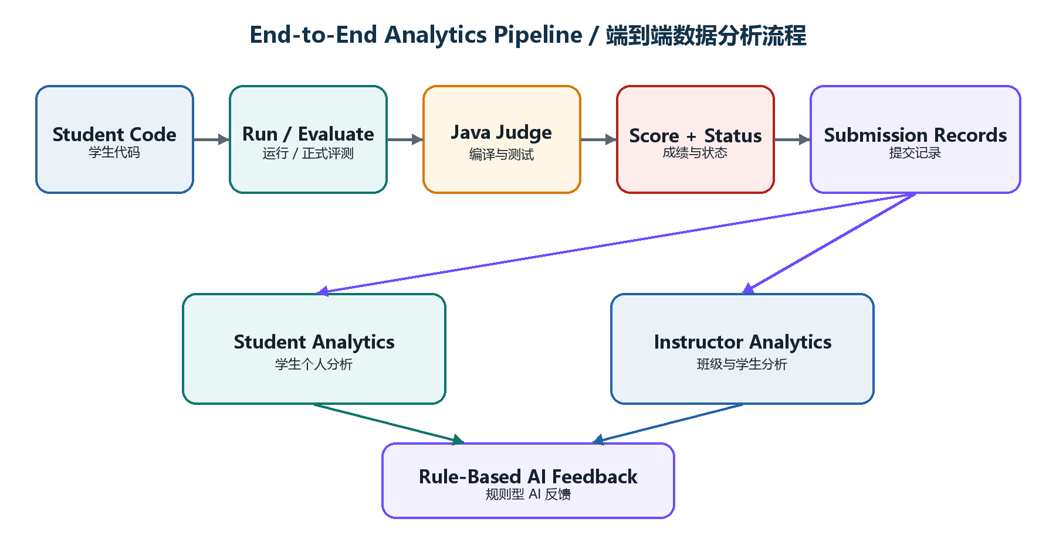
图 1：成绩、分析与 AI Feedback 的端到端流程 / Figure 1. End-to-end scoring, analytics and AI feedback flow
数据实体 / Entity | 关键字段 / Key fields | 用途 / Purpose
submissions | score, status, judge_status, test_passed, test_total, evaluated_at | 成绩、错误率、趋势与提交状态  Scores, error rates, trends and submission state
submission_test_results | passed, run_status, weight, duration_ms | 测试用例证据  Per-case evidence
questions | topic, subtopic, difficulty, chapter_title | Topic、难度和章节聚合  Topic, difficulty and chapter grouping
assignments / assignment_questions | assignment_id, marks, question_order | 作业范围和题目映射  Assignment scope and question mapping
class_students / students | class_id, student_id | 班级成员与教师筛选  Class roster and instructor filtering

2.1 最新记录去重 / Latest-record deduplication
学生个人分析按 assignment_question_id 保留最新记录；教师班级分析按 student_id + assignment_question_id 保留最新记录。这避免同一道题被反复 Evaluate 后重复影响平均分。
Student self-analytics keeps the latest row per assignment_question_id. Instructor class analytics keeps the latest row per student_id + assignment_question_id. This prevents repeated Evaluate attempts on the same question from multiplying its effect on averages.
分析页面 / View | 平均分样本 / Score sample | 错误率样本 / Error-rate sample | 查询上限 / Limit
学生个人 / Student self | 每题最新记录  Latest per question | 全部历史尝试  All attempts | 100
教师班级 / Instructor class | 每个学生每题最新记录  Latest per student-question | 全部历史尝试  All attempts | 2,000
教师单个学生 / Instructor student | 每题最新记录  Latest per question | 每题最新记录  Latest per question | 1,000

3. Judge 评分与状态计算 / Judge Scoring and Status Calculation

3.1 测试用例通过条件 / Test-case pass condition
测试用例只有在程序运行状态为 success，且实际输出满足指定比较模式时才计为通过。隐藏案例和样例都可以设置独立 weight。
A test case passes only when the run status is success and actual output matches the selected comparison mode. Hidden and sample cases may each carry an independent weight.
模式 / Mode | 比较规则 / Comparison rule | 典型影响 / Typical effect
exact | 实际字符串必须与预期字符串完全相同  Actual string must equal expected exactly | 空格、换行均敏感  Whitespace and line breaks matter
trim | 统一换行并忽略整体首尾空白  Standardize newlines and trim outer whitespace | 默认模式  Default mode
normalize | 统一换行、trim，并把连续空白压缩为一个空格  Standardize, trim and collapse whitespace | 适合宽松文本比较  Useful for tolerant text matching

题目成绩 / Question score
Score = round(100 × Σ(wᵢ × Iᵢ) / Σwᵢ, 2)
wᵢ 为测试权重；Iᵢ 通过时为 1，否则为 0。
wᵢ is the test weight; Iᵢ equals 1 for a pass and 0 otherwise.

代码片段 1：权重成绩计算 / Code 1. Weighted score calculation
$score = $totalWeight > 0
? round(($earnedWeight / $totalWeight) * 100, 2)
: 0.0;
$evaluation['status'] =
$earnedWeight >= $totalWeight ? 'passed' : 'failed';
Source / 来源: app/Services/Judge/EvaluateService.php:176-180

3.2 Judge Status 映射 / Judge-status mapping
条件 / Condition | 保存状态 / Stored judge_status | 说明 / Meaning
全部测试通过 / All tests pass | accepted | 最终通过  Final acceptance
compile_error 或 compile_timeout | compile_error | 编译阶段失败  Compilation-stage failure
timeout | time_limit_exceeded | 运行超时  Time limit
runtime_error | runtime_error | Java 异常或非零退出  Java exception or non-zero exit
output_limit_exceeded | runtime_error | 输出过量当前保存为 runtime_error  Output overflow is currently stored as runtime_error
其余未通过 / Other failed outputs | wrong_answer | 输出与预期不匹配  Output mismatch

重要 / IMPORTANT
AI Feedback 的 severity 或 error_type 不参与 Score 公式；AI 不会修改官方成绩。
AI feedback severity and error_type do not participate in the score formula; the AI never changes the official score.

4. 学生端数据分析 / Student Analytics

4.1 指标与公式 / Metrics and formulae
指标 / Metric | 公式或统计口径 / Formula or scope | 样本 / Sample
Evaluate Records | count(all attempts) | 全部历史尝试  All attempts
Evaluated Questions | count(latest per assignment_question) | 每题最新  Latest per question
Average Score | round(Σ latest scores / N, 2) | 每题最新  Latest per question
Best Score | max(latest scores) | 每题最新  Latest per question
Latest Score | scores[0] | 时间最新记录  Most recent record
Accepted Rate | accepted attempts / all attempts × 100% | 全部尝试  All attempts
Compile Error Rate | compile_error attempts / all attempts × 100% | 全部尝试  All attempts
Wrong Answer Rate | wrong_answer attempts / all attempts × 100% | 全部尝试  All attempts
Submitted Assignments | count(distinct assignment_id where status=submitted) | 全部尝试  All attempts
Topic Average | Σ topic latest scores / topic record count | 每题最新  Latest per question
Pass Rate | (accepted OR score≥100) / latest records × 100% | 每题最新  Latest per question
Assignment Activity | attempt count + historical average by assignment | 全部尝试  All attempts
Difficulty / Chapter | average score grouped by metadata | 每题最新  Latest per question

平均值与比率 / Average and rate
Average = round(Σx / N, 2) | Rate = round(Count / Total × 100, 2)
没有样本时返回 0.00。
The implementation returns 0.00 when the sample is empty.

4.2 趋势判断 / Trend classification
最近趋势 / Recent trend
Δ = mean(newest 3) − mean(oldest 3)
记录少于 4 条时为 stable；Δ≥10 为 improving；Δ≤−10 为 dropping；其余为 stable。
Fewer than four records means stable; Δ≥10 means improving; Δ≤−10 means dropping; otherwise stable.

边界行为 / EDGE BEHAVIOUR
只有 4 或 5 条记录时，newest 3 与 oldest 3 会重叠，因此趋势变化会被稀释。
With only four or five records, the newest-three and oldest-three windows overlap, which dampens the measured trend.

4.3 学习表现与 Topic 分级 / Performance and topic grading
范围 / Range | 学生摘要 / Student summary | Topic 反馈 / Topic feedback | 颜色 / Colour
无记录 / No records | No evaluated submissions | No topic data | Neutral / 灰
≥ 80% | Performing strongly | Strong / Keep warm | Success / 绿
50%–79.99% | Making progress | Targeted attempts | Warning / 金
< 50% | Core review recommended | Weak / Revisit examples | Danger / 红

4.4 学生 AI 风险 / Student AI risk
风险 / Risk | 触发条件 / Trigger condition | 主要动作 / Primary action
no_data | attempts = 0 | 先完成一次 Evaluate  Complete one Evaluate
high | average < 50 OR compile ≥ 50% OR wrong ≥ 60% | 优先修复基础语法或核心逻辑  Prioritize syntax or core logic
medium | average < 70 OR compile ≥ 30% OR wrong ≥ 40% | 针对最低 Topic 练习  Practice the weakest topic
low | 未触发以上条件  No higher condition triggered | 持续练习并检查隐藏边界  Continue practice and edge-case review

代码片段 2：学生风险分级 / Code 2. Student risk grading
if ($attempts === 0) return 'no_data';
if ($average < 50 || $compileErrorRate >= 50
|| $wrongAnswerRate >= 60) return 'high';
if ($average < 70 || $compileErrorRate >= 30
|| $wrongAnswerRate >= 40) return 'medium';
return 'low';
Source / 来源: app/Services/AI/RuleBasedAiEngine.php:136-155

5. 教师端数据分析 / Instructor Analytics
教师端包括 Class Analytics 和 Student Analytics。班级平均、Topic、排名、难度和时间线主要使用每个学生每道题的最新记录；Error Type Breakdown 使用全部历史尝试。
The instructor area includes Class Analytics and Student Analytics. Class average, topic, ranking, difficulty and timeline mainly use the latest record per student-question; Error Type Breakdown uses all historical attempts.

5.1 班级核心公式 / Core class formulae
班级平均分 / Class average
ClassAverage = round(Σ latest student-question scores / latest record count, 2)
这是记录级平均，不是“先算每位学生平均，再算全班平均”。完成题目较多的学生会贡献更多记录。
This is a record-level mean, not a mean of student means. Students who complete more questions contribute more records.

作业完成率 / Assignment completion
AssignmentCompletion = min(100, UniqueSubmittedStudents / EnrolledStudents × 100)
Class Completion 等于所有作业完成率的算术平均。
Class Completion is the arithmetic mean of all assignment completion rates.

Topic 通过率与热图风险 / Topic pass rate and heatmap risk
TopicPassRate = Σtest_passed / Σtest_total × 100 | TopicRisk = clamp(100 − TopicAverage, 0, 100)
Topic 平均越低，热图风险值越高。
A lower topic average produces a higher heatmap risk value.

5.2 班级图表与排名 / Class charts and ranking
组件 / Component | 计算 / Calculation | 显示规则 / Display rule
Score Distribution | 最新题目记录按 0–49、50–64、65–79、80–100 分桶  Bucket latest records | 不是学生最终等级人数  Not final student-grade counts
Timeline | 按日期计算最新记录日均分  Daily mean of latest records | 最多最近 8 个日期  Last eight dates
Student Ranking | 按学生最新记录平均分降序  Sort student mean descending | 排除无活动学生，最多 8 人  Exclude no-activity; top eight
Difficulty Analysis | 同难度成绩平均 + accepted/count  Mean score + accepted/count | 按平均分升序  Ascending by average
Error Breakdown | status count / all attempts × 100% | 使用全部历史尝试  Uses all attempts

5.3 教师端学生风险名单 / Instructor student-risk roster
条件 / Condition | 标签 / Label | Severity
submission_count = 0 | No activity | warning
average < 50 | x% avg | danger
50 ≤ average < 65 | Needs support | warning
average ≥ 65 | Stable | success

5.4 班级 AI 风险 / Class AI risk
等级 / Level | 触发条件 / Trigger condition | 界面颜色 / UI severity
no_data | submission_count = 0 | warning
high | class average < 50 OR risk students ≥ 5 OR completion < 50 | danger
medium | weak topic exists (<55) OR any risk student OR completion < 70 | warning
low | 无以上风险  No higher risk triggered | success

OR 规则 / OR LOGIC
风险条件之间采用 OR：任意一个条件达到阈值，即进入相应等级。High 优先于 Medium。
Risk conditions use OR logic: any triggered threshold is sufficient. High takes precedence over Medium.

6. AI Engine 错误识别 / AI Engine Error Recognition
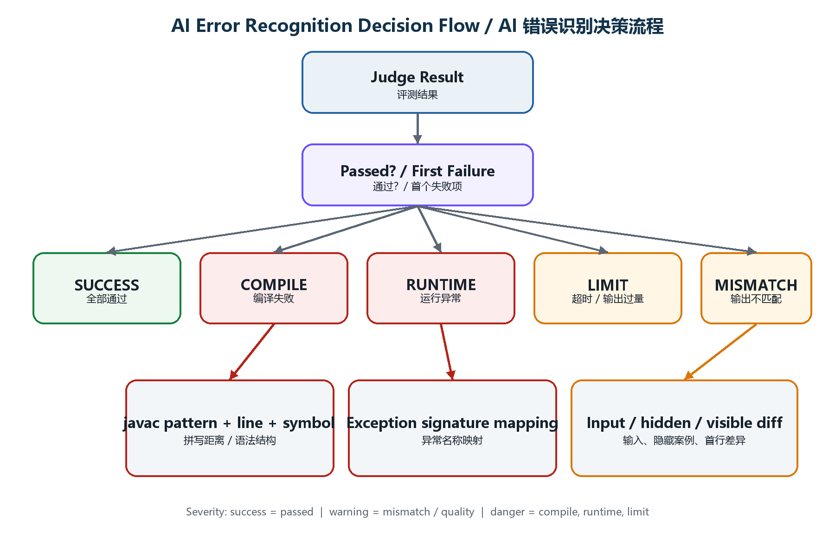
图 2：AI Engine 主错误分类决策流程 / Figure 2. Main AI Engine error-classification flow
AI Engine 不自行编译或执行代码，而是消费 Judge 的 status、stderr、stdout 和测试用例结果。Evaluate 分析以第一个失败案例为主；编译分析通常以第一条 javac 错误为主。
The AI Engine does not compile or execute code itself. It consumes Judge status, stderr, stdout and test-case results. Evaluate analysis is driven primarily by the first failed case; compile analysis is usually driven by the first javac error.

6.1 主分类优先级 / Primary classification priority
优先级 / Priority | Judge 结果 / Result | AI 输出 / AI output | Severity
1 | status = passed | None / Passed official cases | success
2 | compile_timeout | Compiler Timeout | danger
3 | compile_error | Specific compile type | danger
4 | runtime_error | Specific exception type | danger
5 | timeout | Time Limit Exceeded | danger
6 | output_limit_exceeded | Output Limit Exceeded | danger
7 | success run + mismatch | Wrong Answer subtype | warning

6.2 编译错误细分 / Compile-error subtypes
javac 信号 / Signal | AI error_type | 检查重点 / Review focus
';' expected | Missing Semicolon | 本行及上一行语句结尾  Current and preceding statement
')' expected | Missing Closing Parenthesis | 方法调用、if/for/while  Calls and control headers
'}' expected / EOF while parsing | Missing Closing Brace | class、main 和代码块闭合  Class, main and block closure
unclosed string literal | Unclosed String Literal | println 字符串双引号  String quotes
incompatible types | Type Mismatch | 预期类型与实际类型  Expected vs actual type
required/found or cannot be applied | Method Argument Error | 参数数量与类型  Argument count and types
already defined | Duplicate Declaration | 同一作用域重复名称  Duplicate name in scope
non-static ... static context | Static Context Error | main 中实例成员使用  Instance member from main
must be caught or declared | Unhandled Exception | try/catch 或 throws
else without if | Conditional Structure Error | 邻近括号与分号  Nearby braces and semicolons
illegal start / not a statement | Invalid Java Expression | 运算符、括号和前一行  Operators, brackets, prior line
package ... does not exist | Missing Package or Import | 包名拼写和可用库  Package spelling and libraries
cannot find symbol | Unknown Symbol | 拼写、大小写、声明、import  Spelling, case, declaration, import
public class/file mismatch | Class Name Error | Main.java / public class Main

6.3 拼写错误识别 / Identifier typo recognition
候选接受阈值 / Candidate acceptance threshold
MaxDistance = 1 when length(symbol) ≤ 4; otherwise MaxDistance = 2
系统使用不区分大小写的 Levenshtein 编辑距离，并选择距离最小的候选词。
The system uses case-insensitive Levenshtein edit distance and selects the closest candidate.

候选词由 Java 常用类/方法（如 System、String、Scanner、println、charAt）和当前代码中已声明的变量组成。它不是通用英语拼写检查器。
Candidates combine common Java classes/methods (for example System, String, Scanner, println and charAt) with identifiers declared in the current code. It is not a general English spell checker.
错误 symbol | 建议 / Suggestion | 候选来源 / Candidate source
ystem | System | 内置 Java 候选  Built-in Java candidate
system | System | 大小写距离  Case-insensitive distance
pritnln | println | 内置方法候选  Built-in method candidate
cout (已声明 count) | count | 当前代码声明  Local declaration

代码片段 3：编辑距离阈值 / Code 3. Edit-distance threshold
$distance = levenshtein($lower, strtolower($candidate));
if ($distance < $bestDistance) {
$best = $candidate;
$bestDistance = $distance;
}
$maxDistance = strlen($symbol) <= 4 ? 1 : 2;
return $bestDistance <= $maxDistance && $symbol !== $best
? $best : null;
Source / 来源: app/Services/AI/AssignmentCodeInsightService.php:690-701

6.4 Runtime Error 映射 / Runtime-error mapping
Java 异常 / Exception | AI 分类 / AI type | 主要提示 / Main hint
ArrayIndexOutOfBounds | Array Index Error | 索引范围与循环边界  Indexes and loop bounds
StringIndexOutOfBoundsException | String Index Error | charAt/substring 与 length()
IndexOutOfBoundsException | Collection Index Error | 索引必须小于 size()
NegativeArraySizeException | Invalid Array Size | 数组长度不能为负  Array size cannot be negative
NullPointerException | Null Reference Error | 对象初始化  Object initialization
InputMismatch / NumberFormat | Input Parsing Error | 输入类型与格式  Input type and format
NoSuchElementException | Input Availability Error | 读取次数超过输入数量  Too many reads
ArithmeticException / by zero | Arithmetic Error | 除数与边界值  Divisor and boundaries
StackOverflowError | Recursion Error | 递归终止条件  Recursive base case
OutOfMemoryError | Memory Limit Error | 无界数组/集合增长  Unbounded data growth
其他 / Other | Runtime Error | 读取异常行并追踪执行  Trace the failing line

当前映射差异 / CURRENT MAPPING DIFFERENCE
OutOfMemoryError 在 Feedback 中会显示 Memory Limit Error，但 Judge 当前通常仍将其保存为 runtime_error。
OutOfMemoryError is presented as Memory Limit Error in feedback, while the Judge currently still tends to store it as runtime_error.

6.5 Wrong Answer 细分 / Wrong-answer subtypes
检测 / Detection | error_type | 规则 / Rule
测试有输入，但代码无输入 API | Input Handling Error | 未发现 Scanner、BufferedReader、Console 或 System.in
隐藏测试失败 | Edge Case Failure | 提示边界值，但不显示隐藏答案  Suggest boundaries without revealing cases
trim 后相同，原始字符串不同 | Output Formatting Error | 空格或换行差异  Whitespace or newline difference
实际输出为空 | Missing Output Error | print 未到达或缺失  Print not reached or absent
预期与实际均为数值 | Calculation Logic Error | 数值计算结果不同  Numeric result differs
其他输出差异 | Wrong Answer | 显示第一个可见不同输出行  Show first visible differing line

6.6 请求级失败 / Request-level failures
在 Judge 完整分析前失败时，analyzeFailure 还能识别 Encoding Error、Assignment Window Error、Attempt Limit Error、Missing Code Error、Test Configuration Error、Judge Availability Error，以及通用 Evaluation Request Error。
When a request fails before full Judge analysis, analyzeFailure can still identify Encoding Error, Assignment Window Error, Attempt Limit Error, Missing Code Error, Test Configuration Error, Judge Availability Error, and a generic Evaluation Request Error.

6.7 Feedback 输出限制 / Feedback output limits
- 每次最多保留 3 个 Knowledge Points。
At most three Knowledge Points are retained.
- 每次最多保留 3 个 Hints/Suggestions。
At most three Hints/Suggestions are retained.
- 每次最多保留 3 个 Checks，重复项会去除。
At most three Checks are retained, with duplicates removed.
- 隐藏案例只给方向，不显示输入、预期输出或完整解法。
Hidden cases provide direction only; input, expected output and full solutions are not disclosed.

7. 分级规则总表 / Consolidated Grading Rules
对象 / Object | Low / Success | Medium / Warning | High / Danger
学生摘要  Student summary | average ≥ 80 | 50 ≤ average < 80 | average < 50
学生 Topic  Student topic | average ≥ 80 | 50 ≤ average < 80 | average < 50
学生 AI Risk  Student AI risk | average ≥70 AND compile<30 AND wrong<40 | average<70 OR compile≥30 OR wrong≥40 | average<50 OR compile≥50 OR wrong≥60
教师风险名单  Roster risk | average ≥65 | no activity OR 50≤average<65 | average<50
班级 AI Risk  Class AI risk | 无更高风险  No higher risk | weak<55 OR any risk student OR completion<70 | average<50 OR risk students≥5 OR completion<50
代码反馈  Code feedback | all tests pass | output mismatch / quality hint | compile / runtime / timeout / output limit

阈值不是统一等级制 / THRESHOLDS ARE NOT A SINGLE SCALE
Weak Topic 在不同页面使用 <50、<55、<60 或 <65。报告第 10 节列出这一实现差异。
Weak Topic uses <50, <55, <60 or <65 in different views. Section 10 documents this implementation difference.

8. 伪代码 / Pseudocode
伪代码 1：学生个人分析 / Pseudocode 1. Student self-analytics
FUNCTION BuildStudentAnalytics(student, currentClass):
attempts ← LOAD evaluated/submitted rows (max 100)
attempts ← FILTER rows to currentClass
latest ← KEEP newest row per assignment_question
scores ← SCORE of each row in latest
average ← ROUND(SUM(scores) / COUNT(scores), 2)
best ← MAX(scores)
rates ← STATUS_COUNTS(attempts) / COUNT(attempts) × 100
topics ← GROUP latest BY question.topic; CALCULATE mean
trend ← COMPARE newest 3 mean WITH oldest 3 mean
risk ← STUDENT_RISK(average, compileRate, wrongRate)
RETURN metrics, topics, trend, risk, recommendations
END FUNCTION
Source / 来源: Derived directly from the current project implementation / 根据当前项目实现整理
伪代码 2：教师班级分析 / Pseudocode 2. Instructor class analytics
FUNCTION BuildClassAnalytics(class):
students ← LOAD class roster
assignments ← LOAD class assignments
allRows ← LOAD evaluated/submitted rows (max 2000)
latest ← KEEP newest row per (student, assignment_question)
classAverage ← MEAN(score in latest)
FOR EACH assignment:
completion ← unique submitted students / roster size × 100
classCompletion ← MEAN(assignment completion)
topics, difficulty, timeline, ranking ← AGGREGATE latest
errorBreakdown ← AGGREGATE allRows BY judge_status
classRisk ← CLASS_RISK(classAverage, completion, weakTopics, riskStudents)
RETURN summary, charts, classRisk, recommendations
END FUNCTION
Source / 来源: Derived directly from the current project implementation / 根据当前项目实现整理
伪代码 3：AI 错误识别 / Pseudocode 3. AI error recognition
FUNCTION AnalyzeEvaluate(code, question, result):
IF result.status = passed:
RETURN success feedback
failed ← FIRST case WHERE passed = false
SWITCH failed.status:
compile_timeout → danger / Compiler Timeout
compile_error → PARSE first javac error; DETECT typo/syntax
runtime_error → MAP exception signature
timeout → danger / Time Limit Exceeded
output_limit → danger / Output Limit Exceeded
success → CHECK input handling, hidden failure, visible diff
LIMIT knowledge, hints and checks to 3 each
RETURN feedback WITHOUT changing result.score
END FUNCTION
Source / 来源: Derived directly from the current project implementation / 根据当前项目实现整理

9. 示例计算 / Worked Examples

9.1 测试用例权重 / Weighted test cases
假设四个测试权重为 1、1、2、2，学生通过第 1、2、3 个测试。通过权重为 4，总权重为 6。
Assume four tests have weights 1, 1, 2 and 2, and the student passes tests 1, 2 and 3. Earned weight is 4 and total weight is 6.
计算结果 / Result
Score = round(4 / 6 × 100, 2) = 66.67%
因为不是全部权重通过，status 为 failed。
Because not all weight passed, status is failed.

9.2 学生风险 / Student risk
学生平均分 72%，编译错误率 35%，Wrong Answer 率 20%。虽然平均分不低于 70，但编译错误率达到 30%，因此风险为 medium。
A student has a 72% average, 35% compile-error rate and 20% wrong-answer rate. Although the average is not below 70, compile errors reach 30%, so risk is medium.

9.3 班级完成率与风险 / Class completion and risk
一个班有 20 人，两份作业分别有 16 人和 10 人完成：完成率为 80% 和 50%，Class Completion 为 65%。若还存在任意风险学生，则班级风险为 medium；若班级平均分低于 50%，则提升为 high。
A class has 20 students. Two assignments are completed by 16 and 10 students: completion rates are 80% and 50%, so Class Completion is 65%. Any at-risk student makes class risk medium; a class average below 50 raises it to high.
班级完成率 / Class completion
(80% + 50%) / 2 = 65%
完成率按作业平均。
Completion is averaged across assignments.

9.4 拼写识别 / Typo recognition
javac 报告 symbol=ystem。系统与候选 System 做不区分大小写比较，Levenshtein 距离为 1；ystem 长度大于 4，允许最大距离为 2，因此给出 did you mean System。
javac reports symbol=ystem. The engine compares it case-insensitively with candidate System; Levenshtein distance is 1. Because ystem is longer than four characters, the maximum accepted distance is 2, so it suggests System.

10. 当前实现差异与限制 / Current Implementation Notes
项目现状 / Current state | 影响 / Effect | 解释 / Interpretation
Weak Topic 阈值为 <50、<55、<60、<65 | 不同页面可能显示不同弱项数量  Different views may show different counts | 学生个人、班级 AI、教师单个学生和班级页面采用不同阈值  Different consumers use different thresholds
学生页面预留三个未返回字段 | Score Distribution、Error Type、Assignment Progress 可能一直为空 | StudentInsightService 当前未返回对应 key
班级错误分布使用全部尝试，其他图表多用最新记录 | 错误率与平均分样本不同  Different statistical samples | 历史错误会保留，但历史低分不会进入最新平均
Assignment marks 未参与 Analytics 平均 | 各题百分比等权  Question percentages are equally weighted | marks 当前用于配置/显示，不用于这些平均公式
4–5 条趋势记录的窗口重叠 | 趋势变化被稀释  Trend is dampened | newest 3 与 oldest 3 有共同记录
主诊断依据第一失败项/第一 javac 错误 | 一次反馈不一定覆盖所有错误  May not cover every simultaneous issue | 目的是优先处理最早、最可能的根因
数据查询有 100/1000/2000 上限 | 大规模历史数据可能被截断  Large histories may be truncated | Demo 当前采用固定 REST 查询上限
OutOfMemory 的显示与存储分类不同 | Feedback=Memory Limit；judge_status 可能=runtime_error | AI 读取 stderr 细分，但 Judge 状态较粗

范围说明 / SCOPE NOTE
以上是当前代码行为的客观记录，不代表本报告已对这些差异实施修复。
The items above document current code behaviour. This report does not implement fixes for any of them.

11. 源码索引 / Source Code Index
文件 / File | 职责 / Responsibility | 关键位置 / Key lines
app/Services/Judge/EvaluateService.php | 测试执行、权重成绩、judge_status、保存记录  Scoring, status and persistence | 101–193, 242–320
app/Services/Judge/OutputComparator.php | exact / trim / normalize 输出比较 | 9–27
app/Services/AI/StudentInsightService.php | 学生个人指标、Topic、趋势和比率  Student metrics, topics, trends and rates | 184–435
app/Services/Analytics/ClassAnalyticsService.php | 班级平均、完成率、分布、排名、风险数据  Class metrics and risk inputs | 27–607
app/Services/Analytics/StudentAnalyticsService.php | 教师端单个学生分析  Instructor student drill-down | 27–389
app/Services/AI/RuleBasedAiEngine.php | 学生/班级风险和建议阈值  Risk and recommendation thresholds | 13–250
app/Services/AI/FeedbackFormatter.php | 学生摘要和 Topic severity | 9–87
app/Services/AI/AssignmentCodeInsightService.php | 编译、运行、Wrong Answer、拼写和反馈限制  Error recognition and feedback | 142–1155
resources/views/student/personal-analytics.php | 学生数据可视化页面  Student visual analytics | 1–351
resources/views/instructor/analytics/class.php | 教师班级可视化页面  Instructor class analytics | 1–423
tests/ai_feedback.php | 拼写、运行错误、输出差异等规则测试  Rule-level tests | 25–132

结语 / Closing Note
LearnAIJava 当前实现的核心特点是可解释性：每一个成绩、风险等级和错误类别都能追溯到明确公式或规则。它适合 Demo、教学说明和项目答辩，但在正式扩展前应统一 Weak Topic 阈值、补齐学生端缺失指标，并决定是否按 marks 加权。
The defining feature of the current LearnAIJava implementation is explainability: every score, risk level and error class can be traced to an explicit formula or rule. It is suitable for demos, teaching explanations and project defence, while a production extension should unify weak-topic thresholds, supply the missing student metrics, and decide whether assignment marks should weight averages.

